**January 08, 2019**

**COUNCIL MEETING**

New Richmond Village Council met in Council Chambers in regular session on Tuesday, January 08th, 2019 at 7:00 pm. Present: Melanie Slade, Richard Feldkamp, Mary Allen, Paul Vanderbosch, Amanda Davidson and Gary Skeene - members; Ramona Carr, Mayor; Theresa Leigh, Clerk; Michael Couch, Interim PoliceChief; Vince Bee, Fire Chief and Greg Roberts, Village Administrator.

Also attending:

David Vornholt - 310 Susanna Way

Nancy Swats

Minutes of December 11th, 2018 Regular Council meeting were presented for approval. Mary Allen motioned to approve, Seconded by Gary Skeene.

Mrs. Slade: yes Mrs. Davidson: yes Mr. Feldkamp: yes Ms. Allen: yes

Mr. Skeene: yes Mr. Vanderbosch: yes

**Visitors:**

**David Vornholt - 310 Susanna Way**: The New Richmond Ohio Business Association (NROBA) re-elected the same officers who held positions in 2018. The Garden Club and the Historical Society also will join efforts with the NRBA in 2019. Currently they are deciding on a date for the 2019 Village Christmas event.

**VILLAGE ADMINISTRATORS REPORT**

**Greg Roberts, Village Administrator:**

* Planning Commission: Will hold a public hearing this Thursday at 6pm concerning the P.U.D. (Planned Unit Development) Application for the Union
* Station subdivision
* Ball Field License Agreement: Current license holder for the ball fields on U.S. 52 have indicated to their members that they will not be using the ball fields 'going forward." The NR Youth Sports Association is currently in good standing with the license agreement. I am sharing the Facebook post and the license agreement with Council should any question arise.
* Shanty Boat and Showboat: Historic New Richmond is looking to possibly host a traveling river history project this summer. A replica 1940's era shanty boat part of a project called "the Secret History of River People" is planning to come down the Ohio River and HNR is considering hosting the project.
* The Clermont County Convention & Visitors Bureau (CVB) has approached the Village about the possibility of becoming the home for the Showboat Majestic. We have let it be known that we are interested as a potential site for the historic boat, but not interested in an ownership stake.

**COMMITTEE REPORTS**

***Personal & Finance Committee***

The Committee met January 7, 2019 at 4:55 pm. Chairperson: Paul Vanderbosch Members present: Gary Skeene and Paul Vanderbosch. Mary Allen was absent. Staff: Mayor Carr, Lynn Baird, Greg Roberts, Mike Couch, Vince Bee Guests: Ken Shearwood

Lynn Baird

* Lynn distributed the December 31, 2018 year-end report. We need a motion to pay bills 9052018 through 1014-2018 and warrants 36204 through 36318 included in the monthly financial packet ($236,653 total)

**A motion to pay bills 9052018 through 1014-2018 and warrants 36204 through 36318 included in the monthly financial packet ($236,653 total)***.*Paul Vanderboschmade the motion; Seconded by Melanie Slade.

Mrs. Slade: yes Mrs. Davidson: yes Mr. Feldkamp: yes Ms. Allen: yes

Mr. Skeene: yes Mr. Vanderbosch: yes

* She also distributed and discussed the enclosed chart about year-end Fund Balances for the six major fund categories (Clerk’s note: final header column in last row should reflect “12/31/2018.)

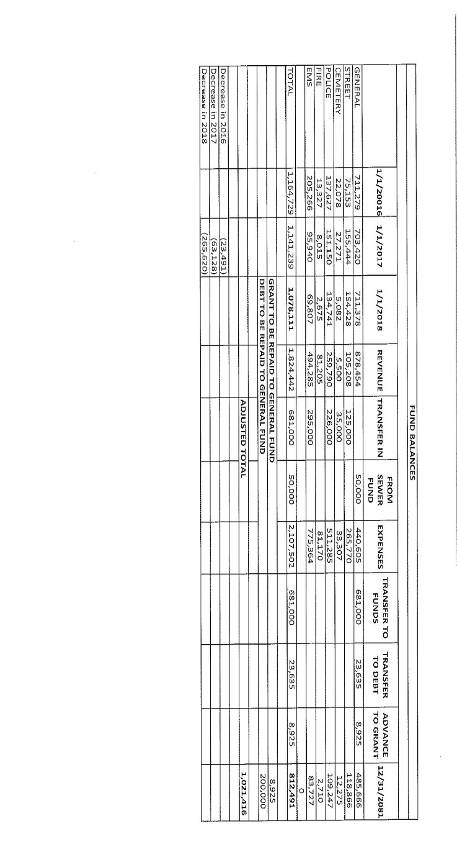

* Columns 1-3 list the "carry-over" fund balances as of January 1, 2016, 2017 and 2018.
* Column 11 lists the carry-over fund balances as of December 31, 2018.
* The carry-over of $1,078,111 decreased by 23% in 2018, down to $812,491.
* The General Fund transferred $681,000 to the other funds as shown.
* She also noted that the carry-over decrease was greater in 2018 than in the two previous years combined.
* Actual expenditures were at 89% of appropriations and revenue was 110% of budgeted
* revenue.
* Budgeted income tax revenue was $520,000 and actual reached $583,000.  The Village has not yet received any flood expense reimbursement.

Vince Bee

Requests the acceptance of the resignation from Tyler Kinman from part-time employee effective January 8, 2019. Tyler leaves in good standing.

**A motion to accept the resignation of Tyler Kinman/part-time employee effective January 8th, 2019.** Paul Vanderboschmade the motion; Seconded by Gary Skeene.

Mrs. Slade: yes Mrs. Davidson: yes Mr. Feldkamp: yes Ms. Allen: yes

Mr. Skeene: yes Mr. Vanderbosch: yes

Mike Couch

* Reported that Floyd Henderson did not accept the offer of a full-time police officer. Mr. Henderson's position ended as of December 21, 2018.
* Also reported that Jordan Meinking is still under consideration as patrol officer for another police department.
* The speed cameras are expected to be operational by the end of January 2019.

Greg Roberts

* He requests that Council rescind its acceptance of Rob Painter's resignation and restore Mr. Painter to his position in the maintenance department without loss of seniority or pay rate.

**A motion to rescind the resignation of Rob Painter effective January 8th, 2019.** Gary Skeenemade the motion; Seconded by Mary Allen.

Mrs. Slade: yes Mrs. Davidson: yes Mr. Feldkamp: yes Ms. Allen: yes

Mr. Skeene: yes Mr. Vanderbosch: yes

* The second reading of the ordinance authorizing the mayor to sign and accept the CDBG is expect at the Council meeting.

The meeting adjourned at 5:45 pm.

***Safety, Laws & Rules Committee***

The Committee met January 7, 2019 at 3:36 pm. Paul Vanderbosch, Gary Skeene, Dick Feldkamp, Greg Roberts, Andrew Gephart, Chief Couch, Chief Bee, Guest Adam Bird, Warren Walker with Duke Energy and Representatives.

* Warren Walker discussed the continuation of the Long Hill Rd. Electric Project; this discussion included Adam Bird from the schools. It could take up to 45 days to complete the project; tentative dates from 3-11 to 5-6-2019.

**A motion to approve the Long Hill Rd. Electric Project road closure from 3/11/2019 to 5/6/2019.** Richard Feldkampmade the motion; Seconded by Gary Skeene.

Mrs. Slade: yes Mrs. Davidson: yes Mr. Feldkamp: yes Ms. Allen: yes

Mr. Skeene: yes Mr. Vanderbosch: yes

Greg Roberts

* Greg and Andrew are drafting a fine of $1,000.00 per day for campers not moved during a High Water Event.
* Water Theft is being investigated. Water Meters are being removed from properties that are vacant and will be reinstalled after an occupancy permit is obtained from the County.
* Greg has asked that Council email set-up information be confirmed by Council members.

Chief Couch

* Chief advised of one Felony arrest already this year.
* He gave us an update for Police Training for this year; it appears to be a great schedule.
* Both 2013 Dodge Chargers are having problems; they are near 100,000 miles each. Chrysler is looking the cars over and will relay what they’ve found.

Chief Bee

* Chief Bee is currently working on a uniform Inspection Program with neighboring departments and jurisdictions.

Meeting adjourned at 4:50 p.m.

***Public Works/Parks/Recreation Committee***

The Committee met January 7, 2019 Chairperson: Amanda Davidson Present: Members: Melanie Slade, Mary Allen, Staff: Greg Roberts.

* We discussed potential projects for the 2019 CDBG grant application.
* Also discussed improvements to the playground park on Hamilton St. across from Dee’s Dairy Bar. Including replacing the antiquated playground equipment.

***Ad Hoc Economic Development Committee***

The Committee met January 8, 2019 at 6:00 pm. Present: Chairperson: Mary Allen; Council Members: Melanie Slade Village Administrator: Greg Roberts Planning Commission Chair: Michael Findlan NROBA: David Vornholt Resident: Betsy Mitchell. Absent: Gary Skeene, Andrew Gephardt, Ramona Carr, Bob Lees, Misty Troutt.

* Marketing Brochure – In anticipation of new houses at Union Station and Regatta, we've developed a marketing brochure that can be used for new Village residents. The goal is to have this brochure in the model homes and given to each new home buyer.
* New Business Work continues in an effort to attract new businesses in the form of: Letters to perspective businesses; Participation in county meetings; Participation in relevant government "help organizations", i.e., Redi Ohio, OEDA (Ohio Economic Development Association), etc.
* We accomplished a number of items on our Action Plan and are looking at the right ones to focus on during the next 3 months.
* We are looking forward to Captain’s Cove moving their whole operation to New Richmond.

***Mike Couch, Interim Police Chief***

* The Department is focusing on 5 areas of training and accreditation: Policy; Laws; Fire Training; Active Shooter; Canine.
* We are working on building up the auxiliary staffing
* The Police Department’s new canine is expected to arrive March 2019
* The Department reported another Felony arrest in addition to the one noted at the Safety, Laws and Rules Committee on 1/7/2019, bringing the total to two Felony arrests to-date in 2019.

***Vince Bee, Fire/Ems Chief:***

* Nothing to report.

***Ramona Carr, Mayor:*** A Vice-Mayor needs to be appointed; she recommends Mary Allen for this position.

Gary Skeene motioned to approve Mary Allen as Vice-Mayor, seconded by Richard Feldkamp.

Mrs. Slade: yes Mrs. Davidson: yes Mr. Feldkamp: yes Ms. Allen: yes

Mr. Skeene: yes Mr. Vanderbosch: yes

***Scott Sollmann, Solicitor***:

* Presented Council with a draft proposal incorporating the Compliance Officer Model for the Village of New Richmond credit card policy and noted the need for Greg Roberts to appoint a Compliance Officer if policy is adopted. This policy needs to be in place by February 2, 2019.
* Submitting a change for CDBG
* Received a Public Records Request from Mr. Gary Lewis.

***Theresa Leigh, Clerk of Council:*** Provided the annual Village Licenses’ update. The license for the boat dock at 411 Front ST expired 12/31/2018; Greg Roberts believes the boat dock is no longer in existence. The Water Tower license agreement with Clermont County Commissioners expired 1/3/2019.

**LEGISLATION**

**First Reading:**

**ORDINANCE 2019-01:** AN ORDINANCE APPROVING, ADOPTING AND ENACTING AMERICAN LEGAL PUBLISHING'S OHIO BASIC CODE, 2019 EDITION, AS THE CODE OF ORDINANCES FOR THE MUNICIPALITY OF New Richmond, Ohio AND DECLARING AN EMERGENCY.

**A motion to suspend the third reading rule for** **ORDINANCE 2019-01:** *AN ORDINANCE APPROVING, ADOPTING AND ENACTING AMERICAN LEGAL PUBLISHING'S OHIO BASIC CODE, 2019 EDITION, AS THE CODE OF ORDINANCES FOR THE MUNICIPALITY OF New Richmond, Ohio AND DECLARING AN EMERGENCY.*Gary Skeenemade the motion; Seconded by Mary Allen.

Mrs. Slade: yes Mrs. Davidson: yes Mr. Feldkamp: yes Ms. Allen: yes

Mr. Skeene: yes Mr. Vanderbosch: yes

**A motion to adopt ORDINANCE 2019-01:** *AN ORDINANCE APPROVING, ADOPTING AND ENACTING AMERICAN LEGAL PUBLISHING'S OHIO BASIC CODE, 2019 EDITION, AS THE CODE OF ORDINANCES FOR THE MUNICIPALITY OF New Richmond, Ohio AND DECLARING AN EMERGENCY.* Gary Skeene made the motion; Seconded by Mary Allen.



**RESOLUTION 2019-01:** A RESOLUTION AUTHORIZING THE SALE DURING CALENDAR YEAR 2019 OF MUNICIPALLY OWNED PERSONAL PROPERTY WHICH IS NOT NEEDED FOR PUBLIC USE, OR WHICH IS OBSOLETE OR UNFIT FOR THE USE FOR WHICH IT WAS ACQUIRED, BY INTERNET AUCTION, PURSUANT TO OHIO REVISED CODE SECTION 721.15(D).

**Second Reading:**

**RESOLUTION 2018-19:** A RESOLUTION AUTHORIZING THE MAYOR TO ENTER INTO AN AGREEMENT WITH THE CLERMONT COUNTY BOARD OF COMMISSIONERS FOR THE 2018 FISCAL YEAR GRANT FOR THE NEW RICHMOND SUSANNA WAY PROMENADE PROJECT

**Third Reading:**

**CALL OF MEMBERS:**

**Paul Vanderbosch –** Nothing to report

**Mary Allen –** Mary will be the guest speaker for Black History Month at the New Richmond Library on February 11th, 2019; 7PM. She will share how the local Underground Railroad and abolitionist history affected her personally.

**Amanda Davidson –** Nothing to report

**Gary Skeene –**  Nothing to report

**Richard Feldkamp** - Nothing to report

**Melanie Slade** - Nothing to report

**Comments from audience:**

**Nancy Swats**: Nancy inquired in to why the EMS were called down to Susanna Way earlier in the day; Fire Chief Bee indicated no details could be shared due to HIPAA laws. Nancy also asked if anyone is looking in to the damage claims posted on the Spencer Park Aviary and Wildlife Center Facebook page. Chief Couch stated no police report had been received from the aviary; Mary Allen explained a police report needs to be filed in order for an investigation.

Mary Allen motioned to adjourn the meeting at 8:10 PM, seconded by Melanie Slade

Mrs. Slade: yes Mrs. Davidson: yes Mr. Feldkamp: yes Ms. Allen: yes

Mr. Skeene: yes Mr. Vanderbosch: yes

Meeting adjourned at 8:10 PM.

___________________ ___________________________

**Mayor Clerk of Council**