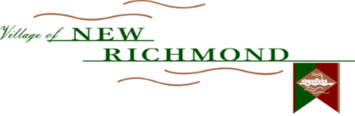

ACH electronic bill payment is a service offered by the New Richmond Utility Department in which pre-authorized electronic funds are automatically withdrawn from your checking account as payment for your bi-monthly bill at no additional cost to you.

Signing up for ACH electronic bill payment eliminates the need for mailing checks, buying stamps, or paying in person! And, best of all, you don’t have to worry about missed payments or late fees!

When your ACH electronic bill payment becomes active, you will continue to receive a statement from New Richmond Utility Department showing your consumption, amount due, and due date.

On the due date shown on your bill (15th day of billing month), we will automatically deduct the amount of your bill from your bank account unless you contact us questioning the amount due, at least 10 business days prior to this date.

Please complete the payment authorization form below, attach a voided check (see below) for verification of bank account information, and return it to:

**New Richmond Utilities**: 102 Willow Street, New Richmond, OH 45157

Yes, I want to (please check one):

Enroll in ACH Update Account Information Cancel ACH

*By signing above I agree to the terms and conditions as set forth by both the New Richmond Utility Department and my financial institution. I authorize the New Richmond Utility Department to charge my checking account for payment of my utility bill. This authority is to remain in effect unless revoked by either New Richmond Utility Department or my financial institution. I understand that I may cancel this arrangement at any time by giving notice in writing to New Richmond Utility Department. Your account must have a zero balance before being set up on ACH. Please allow 30-60 days for activation or cancellation.

Name (As It Appears on Your Bill): Water Account #:

Service Address/City/State: Daytime Phone #:

Routing Number: Account Number:

Bank/Financial Institution Name: Bank/Financial Institution City/State:

Checking Account Signature*:

**Questions?**

**For more information:**

**Phone: (513) 553-4146 Ext. 17**

**Email: nrutilities@newrichmond.org**

**Attach Check Here**

ACH PAYMENT SIGN-UP FORM